THE MACHINE LEARNING CANVAS Designed for: Designed by: Date: Iteration: .
  PREDICTION TASK  Type of task? Entity on which predictions are made? Possible outcomes? Wait time before observation? |   DECISIONS  How are predictions turned into proposed value for the end-user? Mention parameters of the process / application that does that. |   VALUE PROPOSITION  Who is the end-user? What are their objectives? How will they benefit from the ML system? Mention workflow/interfaces. |   DATA COLLECTION  Strategy for initial train set & continuous update. Mention collection rate, holdout on production entities, cost/constraints to observe outcomes. |   DATA SOURCES  Where can we get (raw) information on entities and observed outcomes? Mention database tables, API methods, websites to scrape, etc.
  IMPACT SIMULATION  Can models be deployed? Which test data to assess performance? Cost/gain values for (in)correct decisions? Fairness constraint? |   MAKING PREDICTIONS  When do we make real-time / batch pred.? Time available for this + featurization + post-processing? Compute target? |  |   BUILDING MODELS  How many prod models are needed? When would we update? Time available for this (including featurization and analysis)? |   FEATURES  Input representations available at prediction time, extracted from raw data sources.
 | MONITORING  Metrics to quantify value creation and measure the ML system’s impact in production (on end-users and business)? |  | 

 | Version 1.1. Created by Louis Dorard, Ph.D. Licensed under a Creative Commons Attribution-ShareAlike 4.0 International License.  Please keep this mention and the link to ownml.co when sharing. | OWNML.CO

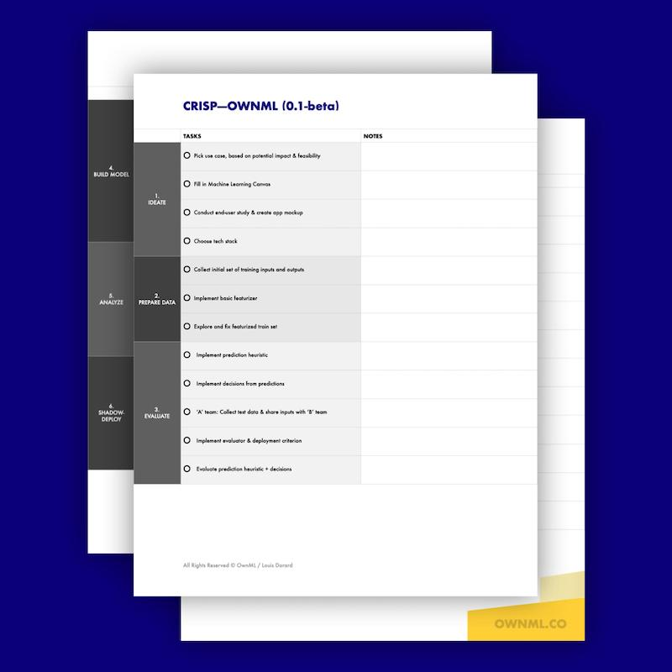

Ready for the next step?
Check out the ML Project Checklist!

Lead ML implementation with confidence with the CRISP—OWNML methodology (Cross-Industry Standard Process to create your own Machine Learning system) and its checklist. End-to-end ML projects are broken down into 9 phases of 4-5 tasks each.

The checklist serves as a roadmap, listing in detail what you need to do, and in which order, so you can minimize risks and make the most efficient use of your (and your team’s) time.

Learn more at ownml.co/checklist

